Using Instruction

1. Line Connection

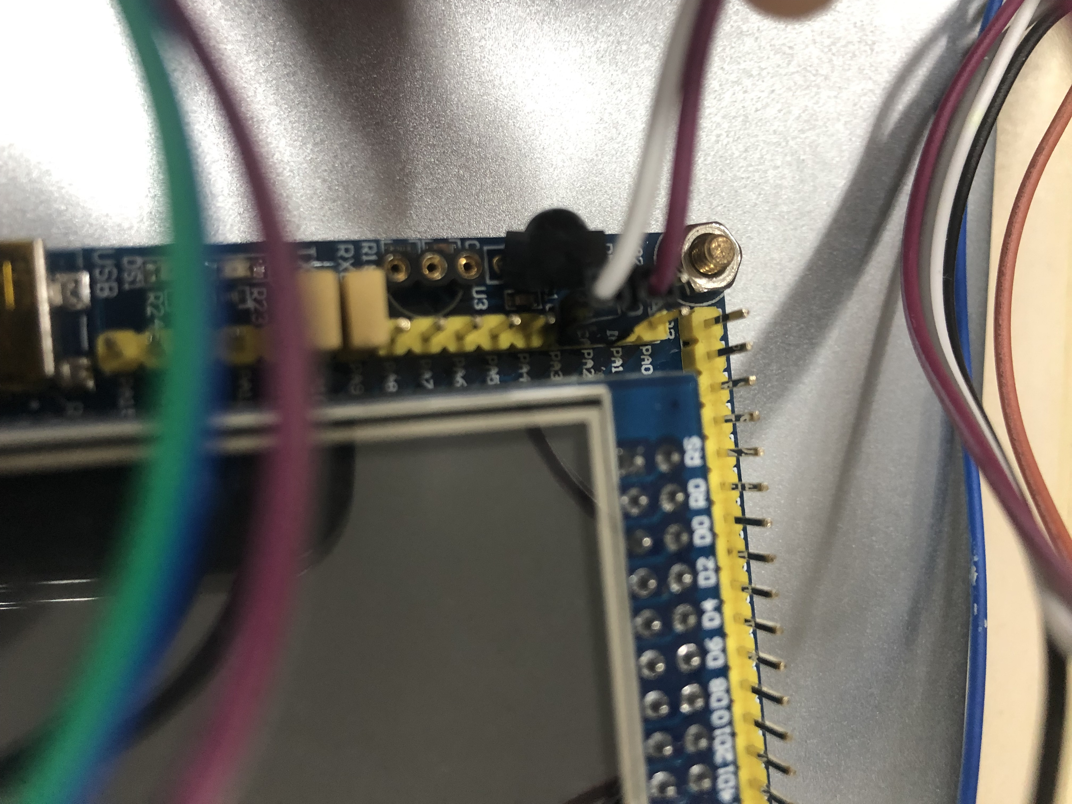 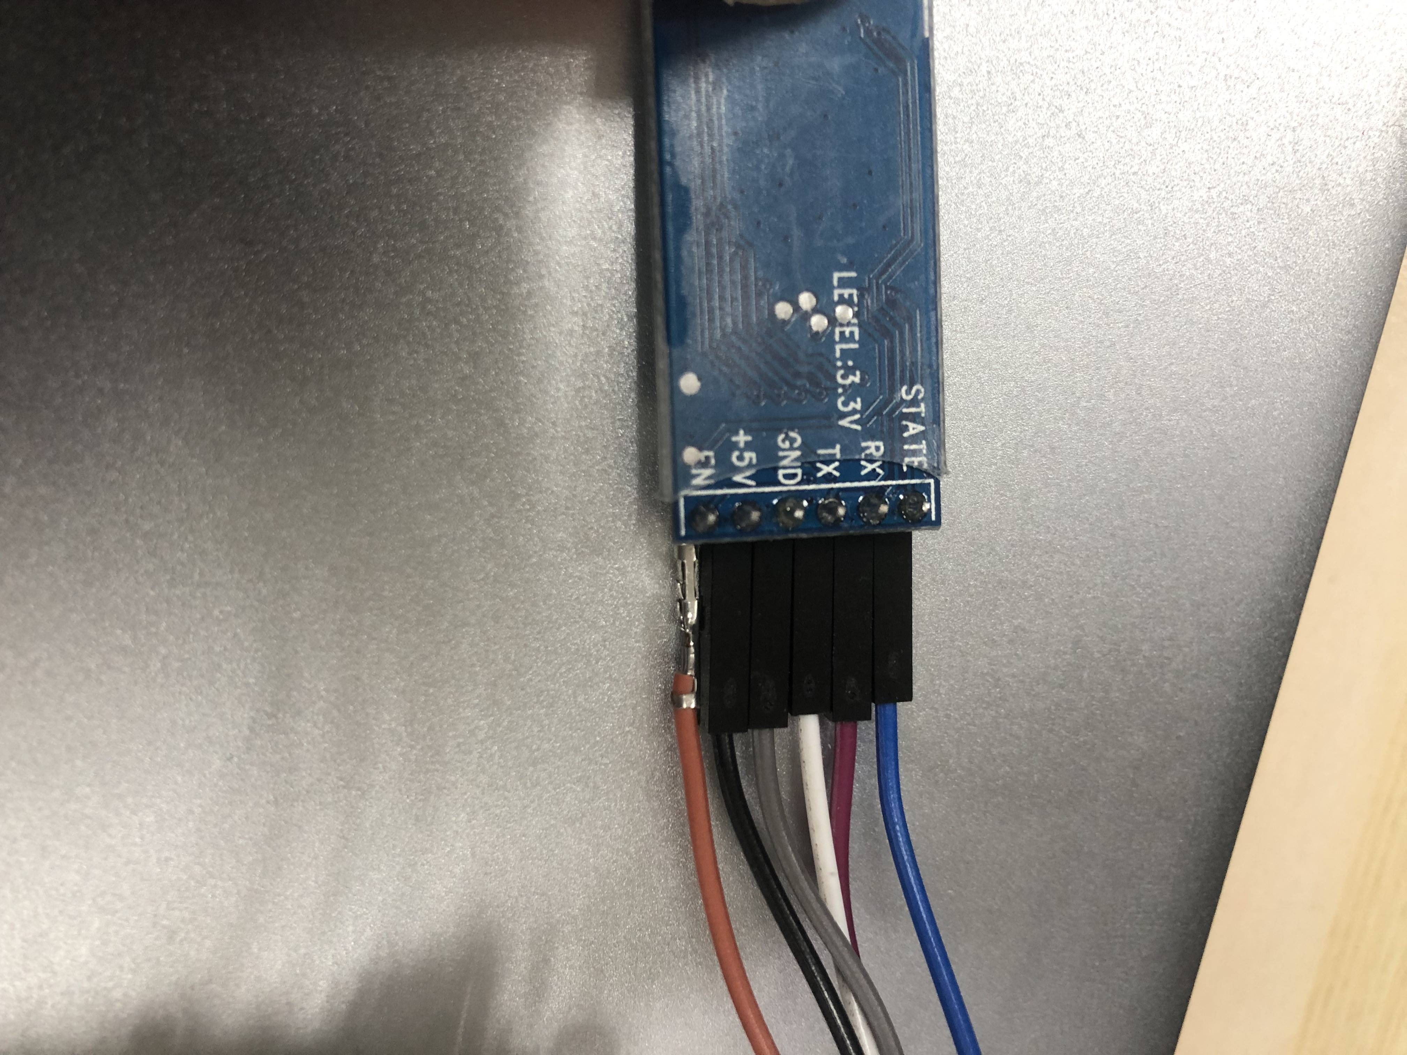 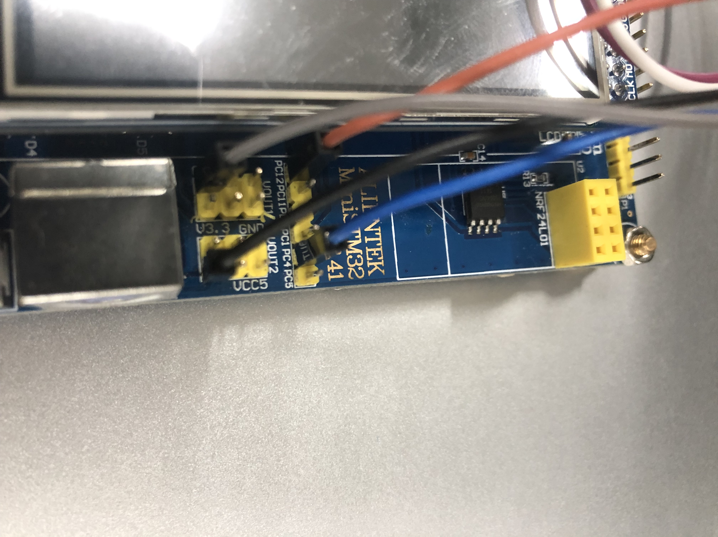

Connect STATE pin on Bluetooth module with PC4 pin on the development board.

Connect EN pin on Bluetooth module with PC12 pin on the development board.

Connect RX pin on Bluetooth module with PA1 pin on the development board.

Connect TX pin on Bluetooth module with PA2 pin on the development board.

Connect power supply pin on Bluetooth module with any corresponding pin on the development board.

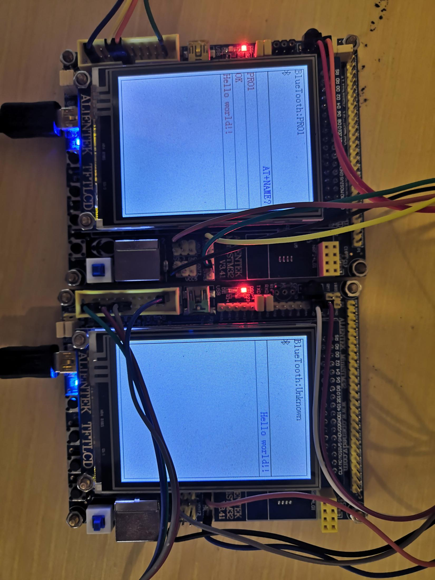

Connect the serial port on the development board with computer.

1. Operating procedure.

Connect development board with computer, turn on the power switch, it will start working. Bluetooth module are in non-working, the block icon on the LCD screen predict that Bluetooth module’s status.

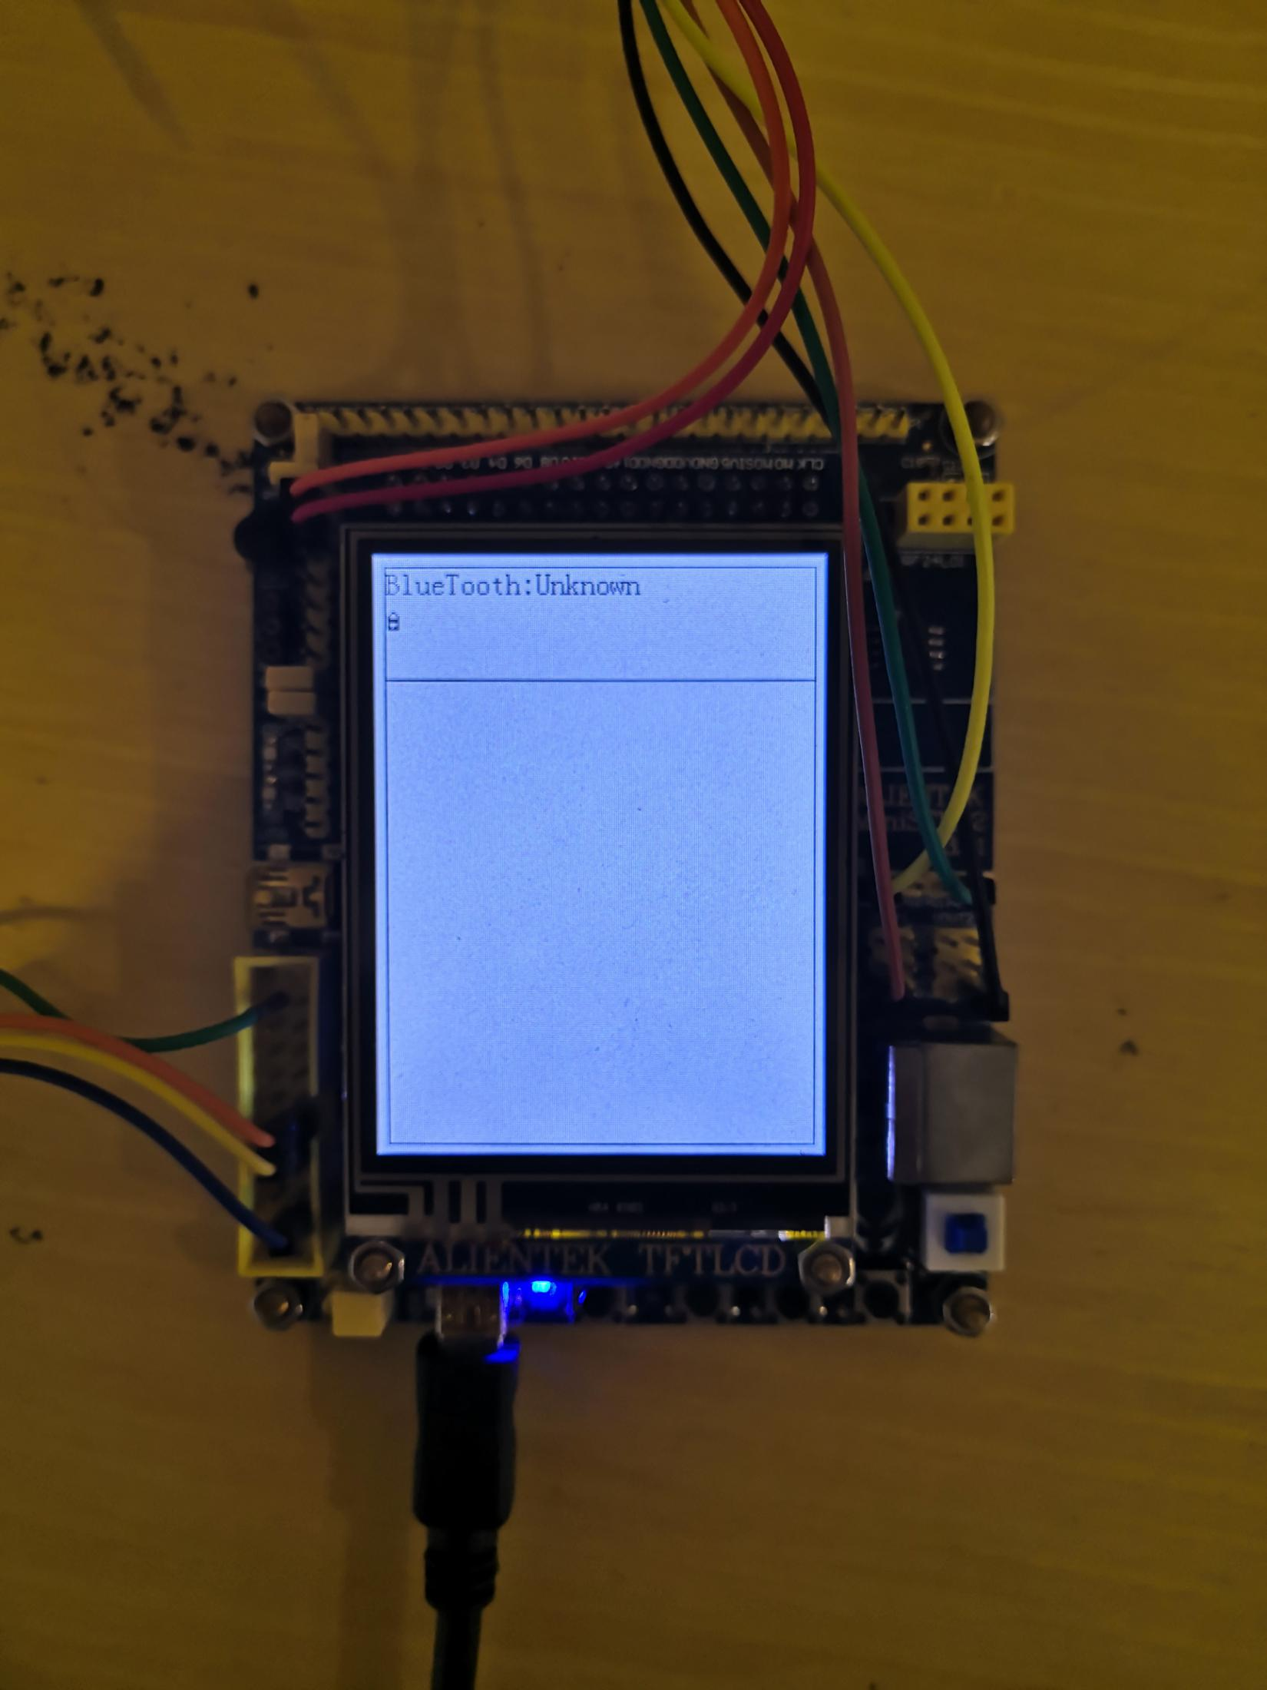

Block icon, state Bluetooth module is turn-off

Initial status.

Press WK UP button, it will turn on the Bluetooth module. LED on Bluetooth module and development board will start blinking, Icon on screen turn to turn-on.

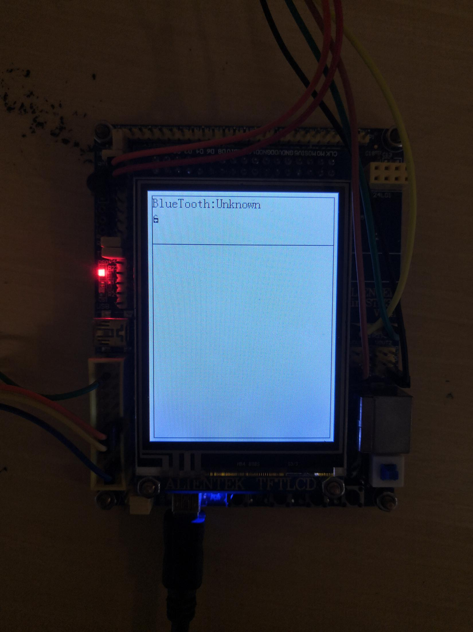

Non-block icon,state that Bluetooth module turn-on.

Press KEY0 button, it will connect the default Bluetooth address;

Press KEY1 button, it will connect any Bluetooth address.

Remember, while press KEY0 or KEY1 you need to long press the button on the Bluetooth module.

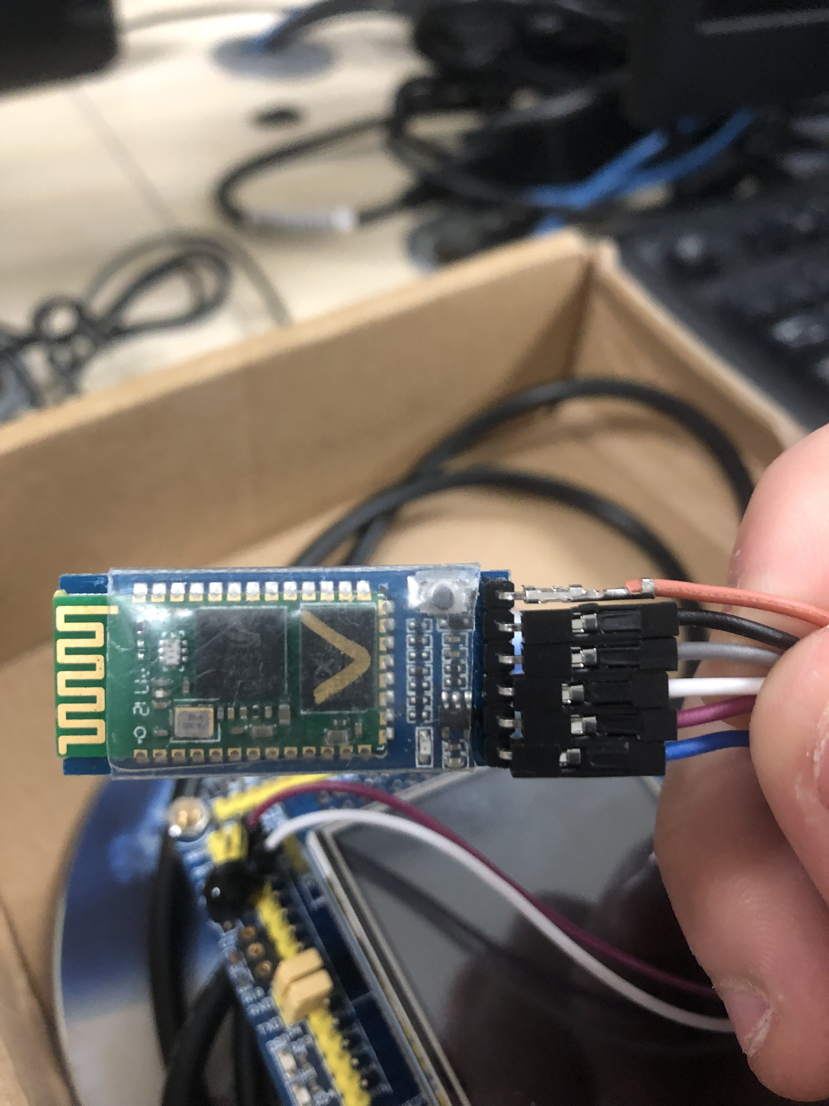

Press the button on the Bluetooth button, it will turn to AT pattern. In this status, type specific instruction can configure Bluetooth module. It is both work at connecting status.

For example, type ‘AT+NAME?’ with carriage return on serial debugging software, it will return the name of the Bluetooth module. And the name will refresh on the top of the screen.

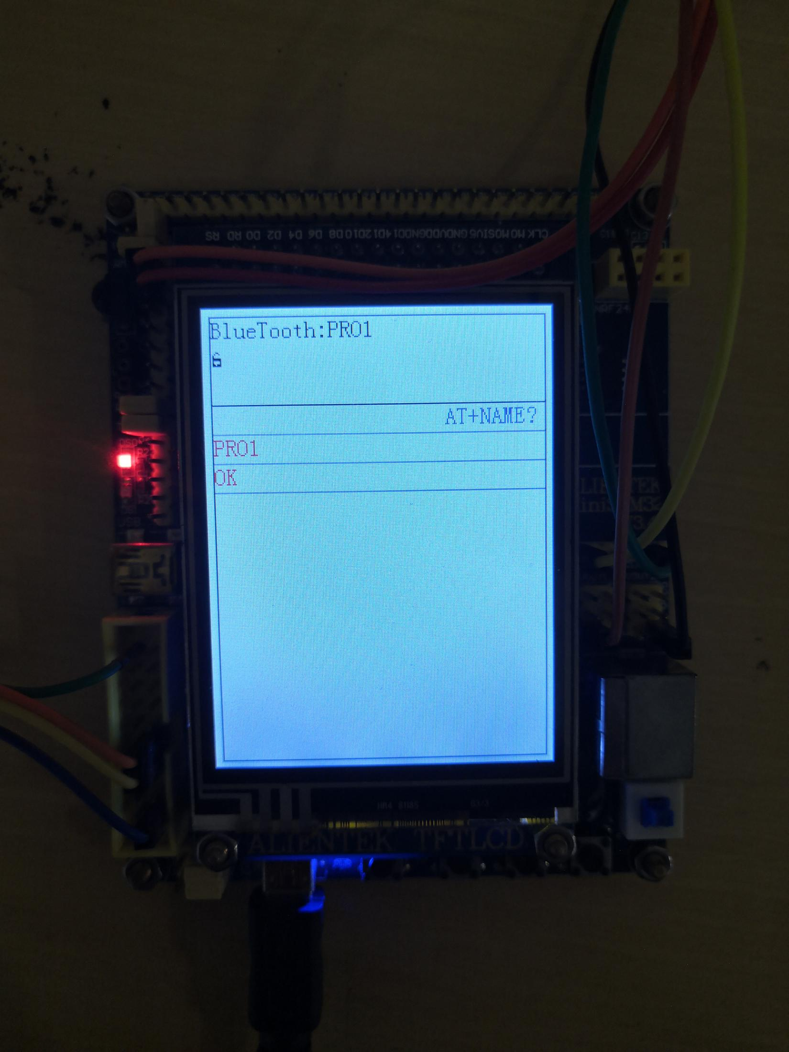

If Bluetooth connect the other one,icon will turn into the Connect.

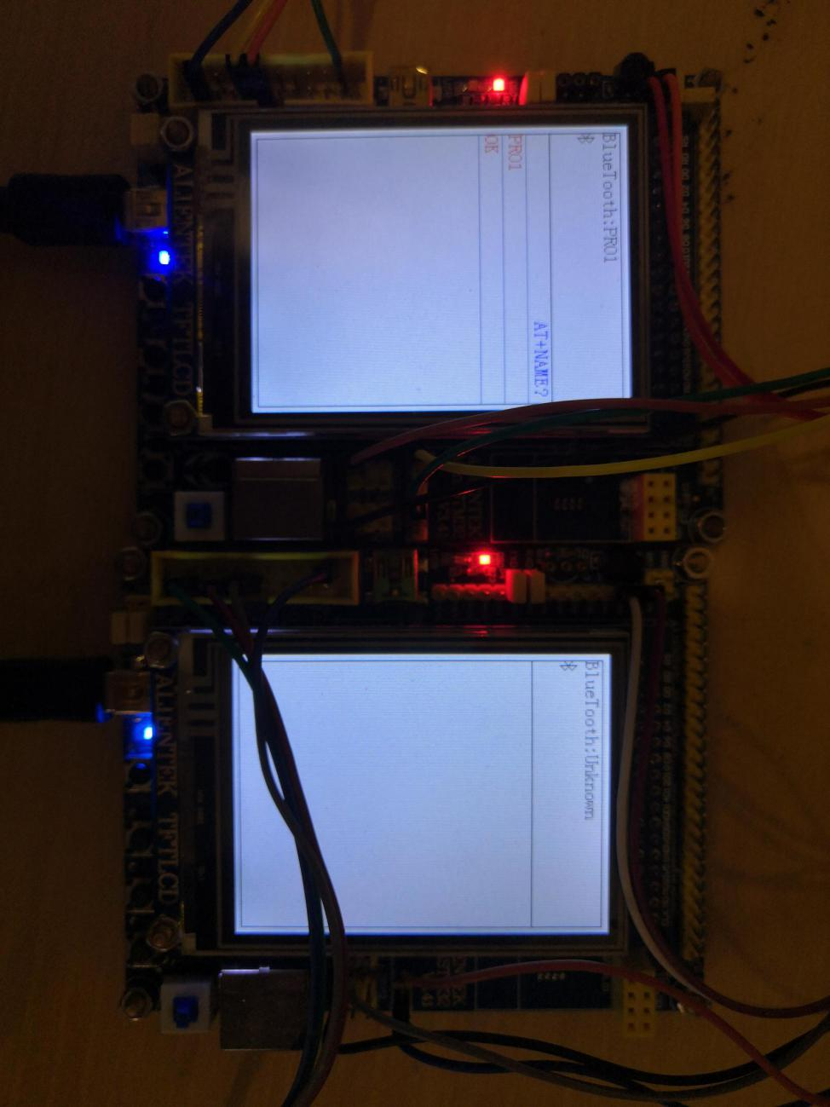

Message from the Bluetooth module

Message from the computer

Connect icon.

In connect status, red LED on the development board will normally on. And LED on the Bluetooth module will flicker once per two seconds.

In connect status, type any chat content with carriage return in the serial debugging software and send, it will transfer to the connected Bluetooth device.

The message trans into the development board from the computer will plot on the right of the screen; message from the Bluetooth module, including chat content from the other device and respond of the Bluetooth module, will plot on the left side of the screen.

Any message sends out and send in from the development board, the green LED on it will light for 1 second.

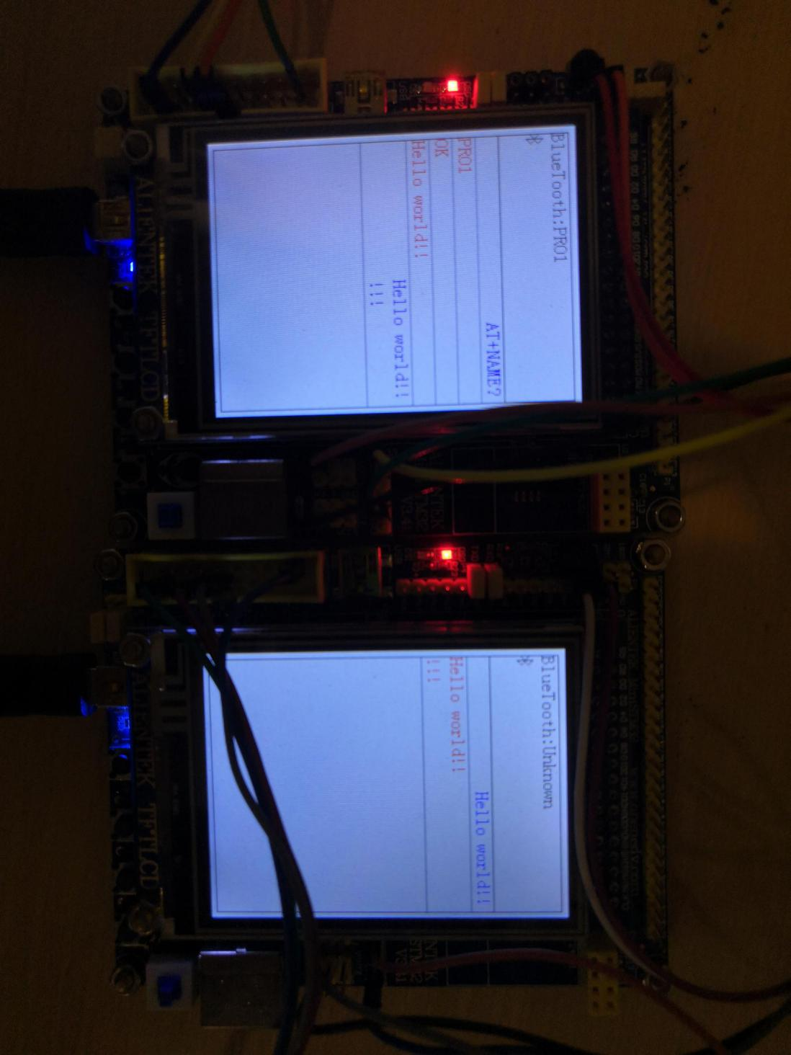

Remember, any message and AT instruction send with serial debugging software must add carriage return at last.